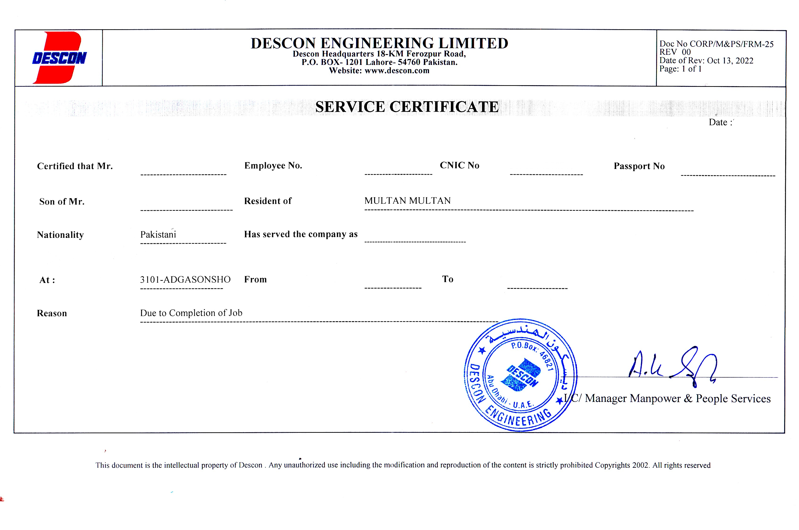

<To>

<Name> 40052085 <CNIC> <Passport>

<fname> , PAK

Work Permit Receiver

<From> <To>